JACKSON MISSISSIPPI

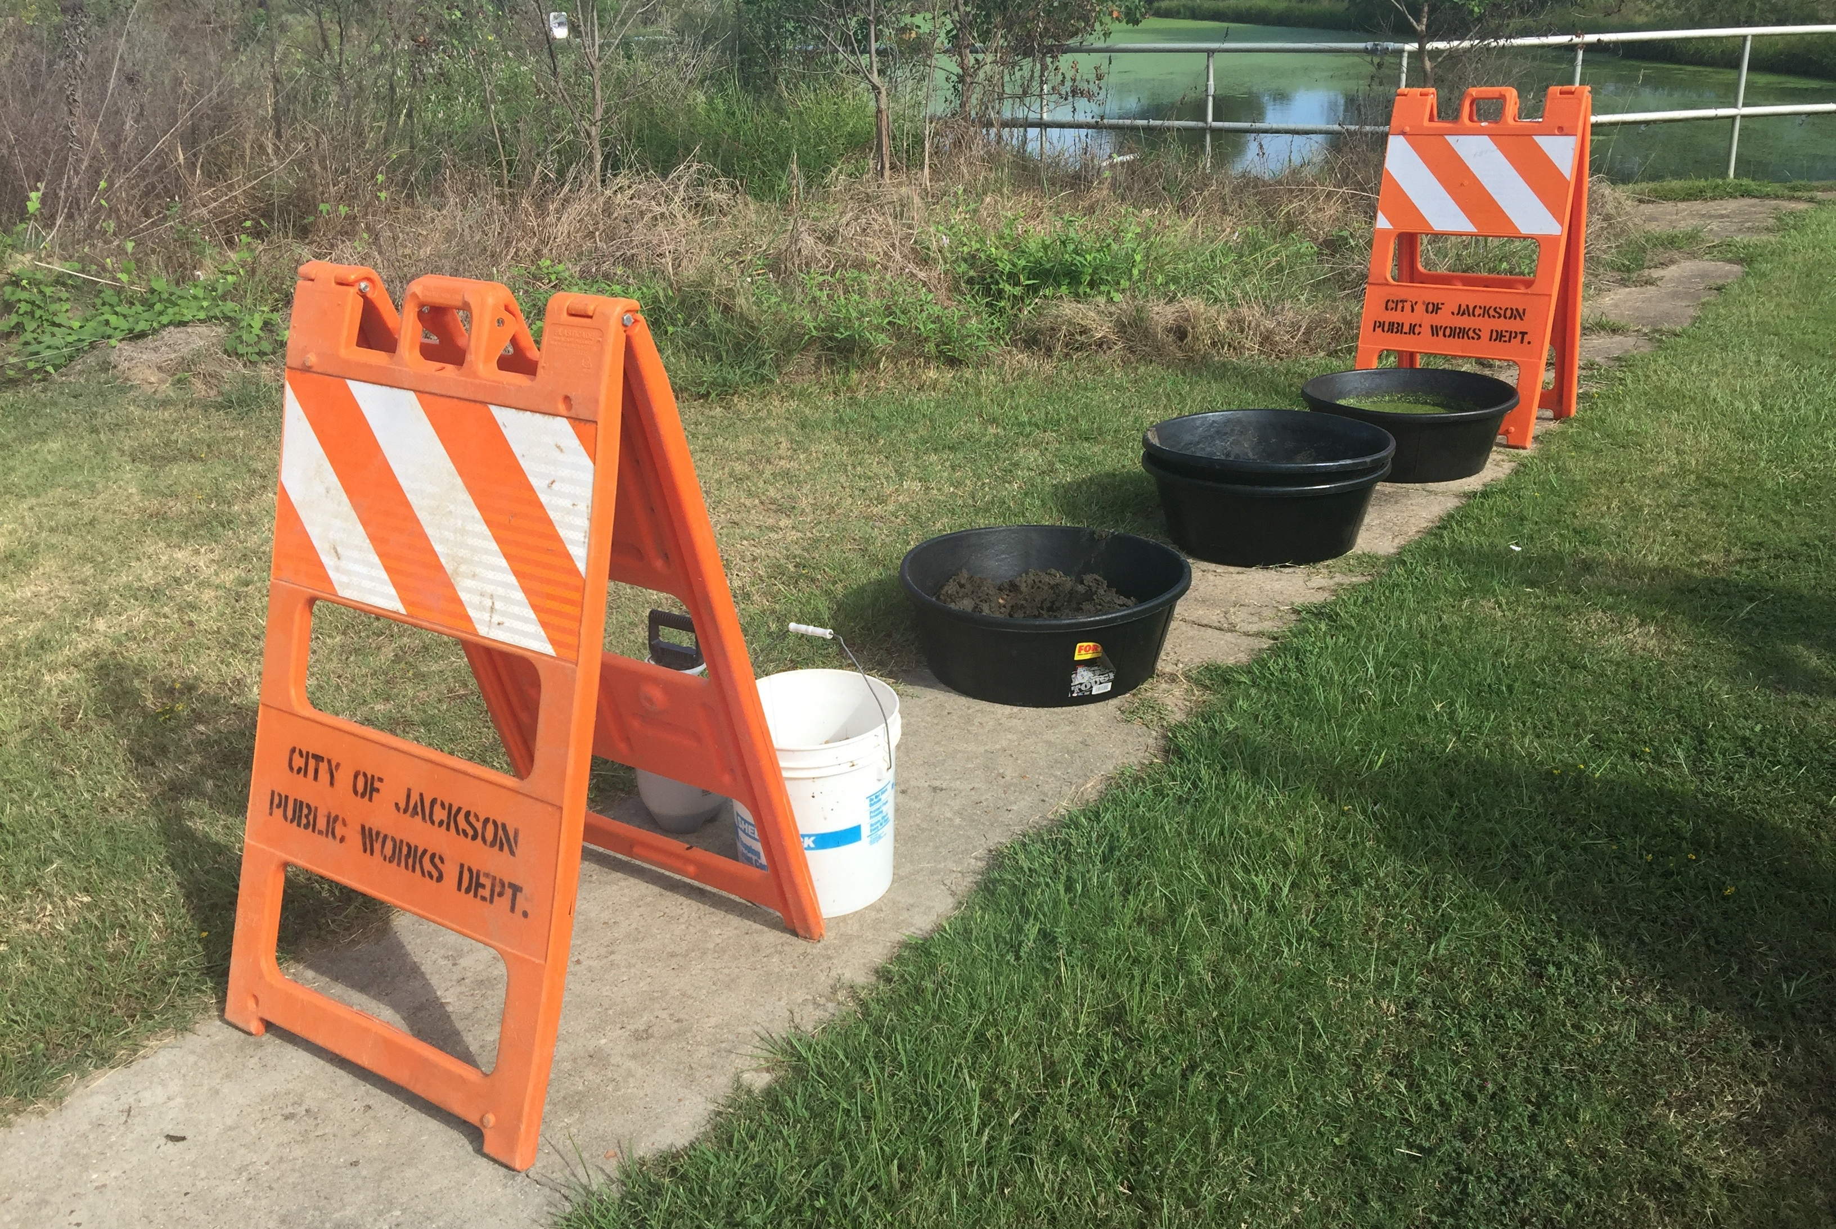

SLUDGE TEST REPORT

OMNITERRA, FALL 2016

PREAMBLE:

A Waste Water Treatment Plant produces various types of sludge. The main sludge is of the secondary type, which is collected daily from the aerator and clarification tanks.
In the case of the visited plant in Jackson, the sludge is of a very fine type, typical of bottom of dams, drying beds or surge dams. The said sludge is normally hydrophobic due to its clay composition. In this case, the sludge has been accumulated on site and covered with plastic. The time line of the accumulation is unknown.
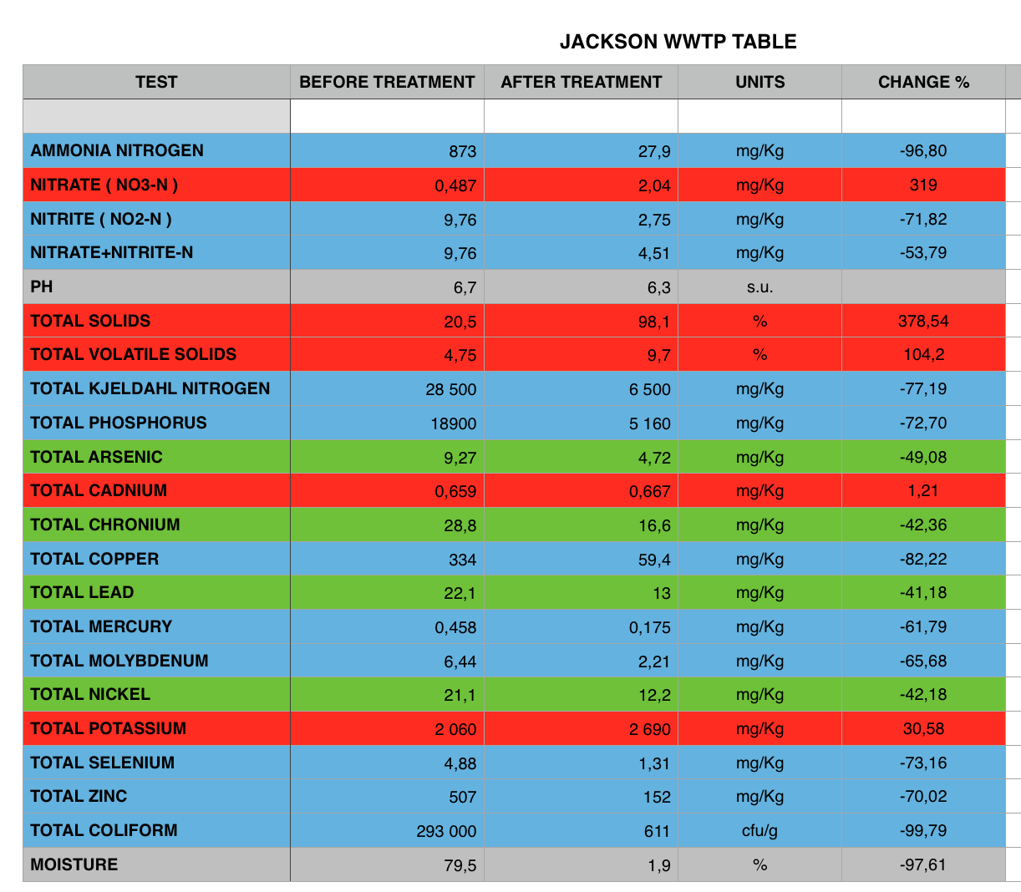
The samples provided were high in Fecal Coliform as the test reports have demonstrated. Below is a comparison table indicating the before and after treatment parameters.
HIGHLIGHTS:
The above colour coding indicates the following:

RED : Compounds increase from untreated sludge
GREEN : Compounds decrease less than 50%
GREY : Irrelevant changes
BLUE: : High level decrease, more than 50%

During natural decomposition of the sludge, some N components will change due to the bio initiation of the de-nitrification shown in this report. The NO3-N has increased due to the natural de-nitrification processes triggered by the Omniterra bacteria introduced to treat the sludge. Overall the N group has decreased substantially as it has been made ready for plant absorption.

The increase in solids in the soil is the result of the applied Omniterra bacteria.

The slight increase in Cadnium reading is due to the ability of the treated soil to release all heavy metals trapped initially by the original hydrophobic sludge.

Potassium increased is due to the release from the soil during the decomposition stage. The Potassium was always in the soil but could not be accurately read in the clumped up sludge. Potassium is not produced but release from the sludge.

The decrease in most heavy metals is only due to the chelation reaction of the Omniterra bacteria where organic bonds are decomposed.

The coliform units are mostly eliminated as Omniterra bacteria will compete for food with all know pathogens found in Fecal coliform.

CONCLUSION:

The before and after laboratory reports clearly demonstrate that the sludge has severely transformed into an beneficial agricultural soil. Once the sludge is bio treated by Omniterra, it can be safely be disposed as top soil. It is pathogen free and has sufficient nutrients to support plant life. It is also safe for all life forms , water tables and soils.

