ERGOFITO MICROMIX
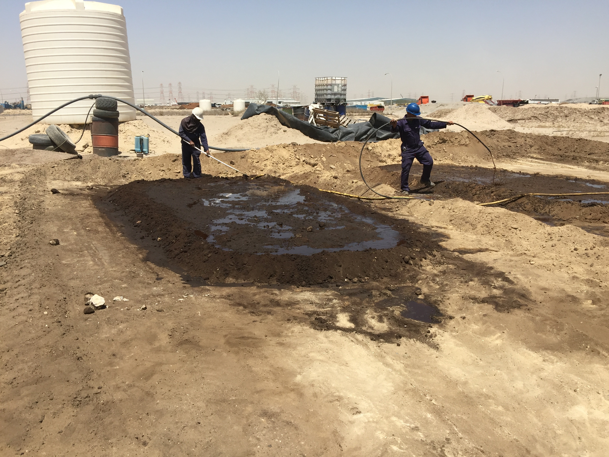
OIL REMEDIATION WORLDWIDE REFERENCES

CAPE TOWN JULY 2016

PREAMBLE:

Ergofito/Micromix natural biological remediation has been successful since its inception in 1995. In soil, water, salt water, rivers, estuaries, open sea, harbours, lakes Ergofito is able to naturally breakdown the long carbon links that all hydrocarbons are made of.

REFERENCES:

Please note that only fraction of Ergofito./Micromix references are disclosed in this document. Our clients names appears when the client has effected the remediation to a tertiary client.

Location:
Client: #26
Houston, Texas
Coastal States Crude Gathering Company

Application: Crude gathering company standardizes on EnviroPro International for hydrocarbon bioremediation in
- carbon concentration on contaminated media – soil, water and air; reducing benzene and/or TPH levels saving time and money making it viable for:
Results: (1) Cleaning and tear down of an 80,000bbl storage tank with over a 1,000bbl of crude oil bottom sludge; was TPH reduction from 78,000ppm to 5,300ppm in 48 hours (93% reduction) and also using EnviroPro HE-1000 the tank was de-gassed in 3 hours. The same bottoms were then treated with MicroMix and rice hulls to compost the tank bot- toms into a organic humus to be used as site fertilizer/fill. (2) Cleaning of a 60,000bbl gasoline tank with over 100bbl of the lab analysis showed the flash point had increased to 145 degrees F. (3) Clean crude bottoms from a 10,000bbl tank with 120 gallons of HE-1000 was pumped into 2700bbl bottom water from an EFR crude tank and after 48 hours lab analysis showed a TPH and benzene reduction by 97% and 90 respectively. The water was approved for on site discharge saving a commercial disposal cost of $40,000.

Case History: 31
Location:
Client:

Application:
closure for Meridian Oil sanctioned by the EPA Region 6 district. EnviroPro International mobilized a treatment trailer and shipped 32 drums of HE-1000 and 10 drums of MicroMix to the site, upon arriving EnviroPro International was met Guard. EnviroPro International gave a short interpretive presentation to have everyone understand the proposed treat- ment protocol. After a short question and answer discussion period EnviroPro began the application process.
Onsite gird sampling was performed by EnviroPro to establish a background level for TPH and any other contaminants that may be present. Sample testing results showed a TPH level of 56,000ppm and non existent for chlorides and any other contaminants. The decision was made that the treatment protocol would only require EnviroPro International’s HE-1000; the HE-1000 would be sufficient to reduce the TPH levels to meet state and federal safe levels. It was also determined that the area had enough indigenous microbes to facilitate the hydrocarbon decomposition so MicroMix would not be required.
Utilizing an onsite available extended reach excavator the operator was instructed to begin stirring the contaminated me- dia while EnviroPro mixed the HE-1000 in a 60 barrel water truck to form a one part chemical to ten parts water solution. A suction hose was then connected from the water truck with the solution to a 2 inch water transfer pump setup to use EnviroPro spray nozzles to apply the chemical/water solution. Once the contaminated media was thoroughly mixed then the application of HE-1000 began. As the chemical/water solution was sprayed over the media the excavator mixed the soil and chemical/water solution together, turning it into a slurry.
Upon agitation of contaminated media, it became apparent that the calculations that EnviroPro was given as contami- nated media volume were miscalculated by over 30%. EnviroPro was faced with a challenge to treat approximately 1700 cubic yards with a chemical/water solution calculated for 1200 cubic yards. EnviroPro applied additional water to wet the contaminated media and worked with the excavator to further breakup the soil and agitate the hydrocarbons. The HE-1000 chemical/water solution was applied and the media mixed for approximately 5-6 hours with the excavator. The pit was then leveled and the process completed. A test sample was taken immediately upon completion of the pit processing to see if there had been any change in TPH levels. The analysis showed a 50% reduction along with a major change in the color and hydrocarbon odor that had been present prior to the application.
Conclusion: Starting with a background TPH level of 56,000ppm, a 50% reduction in TPH occurred immediately upon completion of the process. After 24 hours of process completion soil sampling showed a TPH reduction of 93% and after 48 hours soil sampling revealed a TPH level less than 1 percent, well below the goal of 10,000ppm set by the EPA

Case History: 46
Location: Victoria, Texas
Client : Zapata Oil & Gas

Application: An oil production reserve pit closure measuring 156’ X 186’ X 3’ deep containing a mixture of indigenous
soils, drilling mud and related production waste (approximately 3,224 cubic yards) was sampled for chloride and hydro- with an ECe of 295.3. After much discussion it was determined that an effective protocol would incorporate EnviroPro MicroMix for chloride treatment and HE-1000 to help enhance/feed the MicroMix for hydrocarbon TPH reduction.
On day one 1,200 gallons of MicroMix was mixed with 12,000 gallons of fresh water in an open skid tank and pumped into the pit then distributed with a dozer to thoroughly mix the chemical solution in to the sludge. After mixing the chemi- cal solution in the sludge an additional 12,000 gallons of fresh water was pumped to flood the surface of the pit and left undisturbed for the day. On day two 275 gallons of HE-1000 was mixed with 2,750 gallons of freshwater in an open skid tank and pumped into the pit; again a dozer was used to distribute and mix the chemical solution, then an additional 1000 gallons of freshwater was pumped into the pit to create a slurry. The dozer was removed from the pit after 5 hours. Samples were taken from the pit immediately after the dozer was removed and reveal a TPH level reduction of 5,114TPH down from 83,000ppm (93% reduction in 4 hours) with no visible signs of hydrocarbons in the pit and all hydrocarbon odors eliminated. The Chloride sample taken at the same time revealed a chloride level reduction of 98,000ppm and a ECe of 146 (50% reduction in 48 hours). Three times a week for the next three weeks a dozer was used to turn over the sledge while spraying fresh water mixed with urea and molasses at an 20 to one ratio to ensure the MicroMix was supplied with a food source to help convert all inert organic matter and hydrocarbon waste into humus-creating a healthy nutrient soil.
Results: The in-situ treatment with EnviroPro International MicroMix and HE-1000 for chloride and hydrocarbon con- tamination reduction levels resulted in achieving pit closure in 3 weeks instead of 6-12 months. Final chloride level of 10,000ppm was achieved and hydrocarbon TPH reduction to 1,660ppm for a chloride reduction of 95% and TPH reduction of 98% in the three window.

Case History: #83
Location: Casper Wyoming
Client: Baker Hughes Service Tools

Application: DevelopaplantoremediatecontaminatedsoilunderneathaBakerHughesOilToolsServicewarehouse/ tool shop, staging yard and parking lot located at Casper Wyoming. Contamination was readily noticed because of the strong hydrocarbon odor coming from the building and surrounding areas. A coring company was brought in to drill several test cells to determine just how far below the surface the contamination had migrated. It was determined the con- agency mandates not more than 2,000 PPM is allowable for hydrocarbon contamination. The affected area consisted of area of 150” wide and 250” long and a depth of 18 to 22’ (approximately 30,555 cubic yards). We were informed that a previous decision was made by another cleaning company to work in stages to remove limited amounts of contaminated soil, to treat it and haul it to a land fill for disposal; while requiring the facility to shut down operations. For obvious rea- sons this plan was scrapped. A more non-invasive approach was taken by using a local boring company to drill holes to a depth of 22 feet at a 45 degree angle and turn 90 degrees traveling the width of the building (150’) then back up at 45 degrees. Step two, place perforated 3” PVC pipe every 6’ and manifold together. An EnviroPro HE-1000 water blend of 150 gallons of HE-1000 with 1,500 gallons of water was then injected in to the manifold, an air compressor was then connected to the manifold and the chemical and water blend was forced into the soil via air pressure. The soil being porous accepted the chemical mixture rather quickly; an immediate change in the color of the soil and a reduction in the odor were noticed. Once the leaching process started, samples were taken and the Total Petroleum Hydrocarbons (TPH) showed immediate reduction.
Results: After 8 hours it was recorded the TPH levels had been reduced by 91%. Monitoring continued for 24, 48, 72 hours, 7 days, 14 days and 30 days respectively to ensure TPH safety levels were achieved.
Note: Initial soil testing showed that hydrocarbon was the only contaminate above state mandated levels and the indigenous microbes were sufficient to digest the hydrocarbon contaminate, a protocol of HE-1000 was all that would be required to reduce the TPH levels to Wyoming standards. Had other contaminates been present the protocol would of included a combination of HE-1000 and MicroMix Ergo Sludge.
Conclusion: Using the EnviroPro HE-1000 water blend along with the boring contractor achieved what most would say couldn’t be done; using off the shelf technology and the environmentally safe EnviroPro HE-1000 chemical, heavy without interrupting the clients daily operations.

Case History: #83
Location: Casper Wyoming
Client: Baker Hughes Service Tools
Application: DevelopaplantoremediatecontaminatedsoilunderneathaBakerHughesOilToolsServicewarehouse/ tool shop, staging yard and parking lot located at Casper Wyoming. Contamination was readily noticed because of the strong hydrocarbon odor coming from the building and surrounding areas. A coring company was brought in to drill several test cells to determine just how far below the surface the contamination had migrated. It was determined the con- agency mandates not more than 2,000 PPM is allowable for hydrocarbon contamination. The affected area consisted of area of 150” wide and 250” long and a depth of 18 to 22’ (approximately 30,555 cubic yards). We were informed that a previous decision was made by another cleaning company to work in stages to remove limited amounts of contaminated soil, to treat it and haul it to a land fill for disposal; while requiring the facility to shut down operations. For obvious rea- sons this plan was scrapped. A more non-invasive approach was taken by using a local boring company to drill holes to a depth of 22 feet at a 45 degree angle and turn 90 degrees traveling the width of the building (150’) then back up at 45 degrees. Step two, place perforated 3” PVC pipe every 6’ and manifold together. An EnviroPro HE-1000 water blend of 150 gallons of HE-1000 with 1,500 gallons of water was then injected in to the manifold, an air compressor was then connected to the manifold and the chemical and water blend was forced into the soil via air pressure. The soil being porous accepted the chemical mixture rather quickly; an immediate change in the color of the soil and a reduction in the odor were noticed. Once the leaching process started, samples were taken and the Total Petroleum Hydrocarbons (TPH) showed immediate reduction.
Results: After 8 hours it was recorded the TPH levels had been reduced by 91%. Monitoring continued for 24, 48, 72 hours, 7 days, 14 days and 30 days respectively to ensure TPH safety levels were achieved.
Note: Initial soil testing showed that hydrocarbon was the only contaminate above state mandated levels and the in- digenous microbes were sufficient to digest the hydrocarbon contaminate, a protocol of HE-1000 was all that would be required to reduce the TPH levels to Wyoming standards. Had other contaminates been present the protocol would of included a combination of HE-1000 and MicroMix Ergo Sludge.
Conclusion: Using the EnviroPro HE-1000 water blend along with the boring contractor achieved what most would say couldn’t be done; using off the shelf technology and the environmentally safe EnviroPro HE-1000 chemical, heavy without interrupting the clients daily operations.

CAPE TOWN HARBOUR:

Location: South Africa
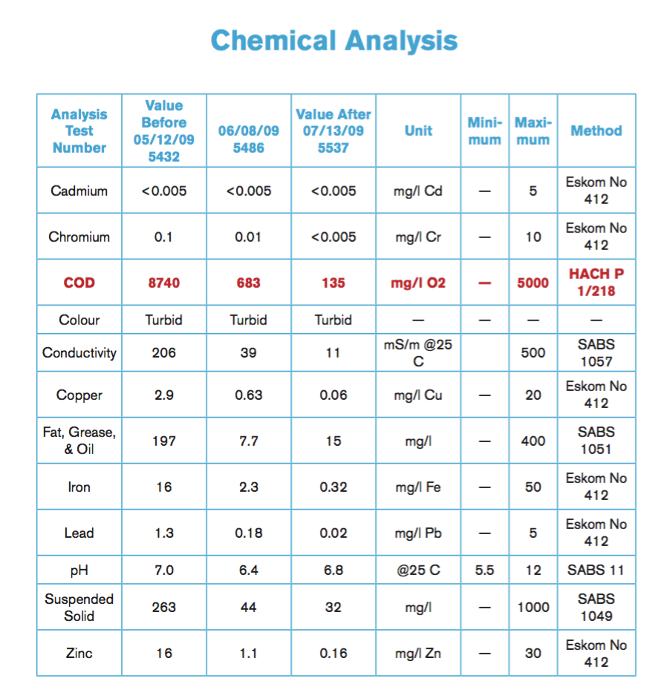
Client: Sputh African Railways

